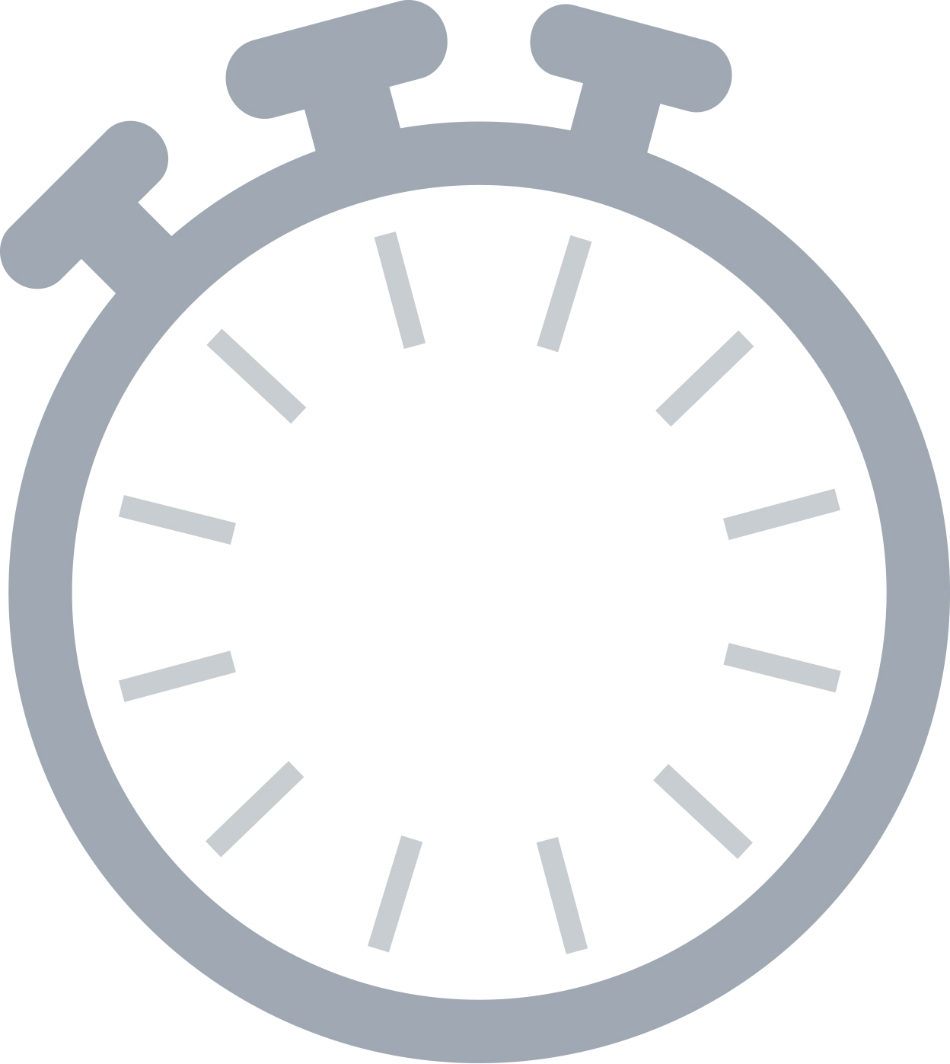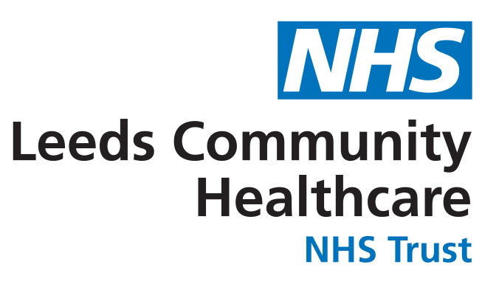

**What do we do?**

Following a screening assessment to clarify what help with can offer; We provide interventions using a Positive Behaviour Support Model to identify the young person’s strengths and needs and support them and their family to move towards meeting their potential.

The team work in a multi-disciplinary way and work across all of the services and settings that support the child/young person. We are often involved in promoting positive physical and mental health and reducing inequalities for our children and young people.

**Who are we?**

We are a city-wide, multi-disciplinary team within Leeds CAMHS.

We support children and young people with moderate and severe Learning Disability, their families and wider support networks, to develop their skills in understanding and managing behavioural presentation by assessing situations and implementing behavioural guidance.

**How to get us involved?**

Referrals are accepted from the young person or anyone involved with the young person. To refer to us please contact MindMate SPA: 0300 555 0324 www.mindmate.org.uk

We can also take internal referrals from within CAMHS. Contact: [camhs.ld@nhs.net](mailto:camhs.ld@nhs.net)

Our opening hours are Monday – Friday 9-5.

One minute guide

Leeds CAMHS – Learning Disabilities Team

V1: 19-07-2022

**60**